Native Video Report
10/06/26  Web Programming | Adam Carling  Dr. Barker

Overview

I added a video to the roux page. The video is stored natively and is not my product. I probably need to list its producer and source to avoid copyright issues, but I have not looked into it yet. I initially wanted to embed the video directly from YouTube. I think that will make the site easier to update in the future, however, that requires that I host the website from a server, which I am not yet ready to do. I also added a video poster by taking a screen shot of a point in the video and saving it as a .png file.
 | Code used
 | 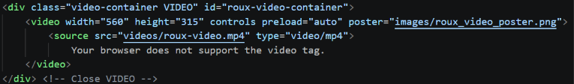  I have decided to only attach the id to the div container for readability. This way, all Class and ID definitions are in the same locations and can be easily found. I have realized I can still access the video and source elements of the container with the following code:  Meaning, I only need the identifiers in the div elements. | Currently, there is only one type of video file and I do not set the MIME type. In the future this might be important, but videos are such a low priority for this project that I don’t think it is worth it.

 |  | instructions for the recipe.
 | Sub-header-content div  I use a div called sub-header-content and create rows and columns with it.  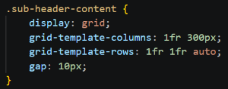  Assigning divs to rows and columns  Each section of the page then gets its own division class and is assigned to a row.  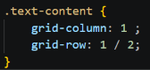  Text-content contains ingredients and any necessary recipe info. | 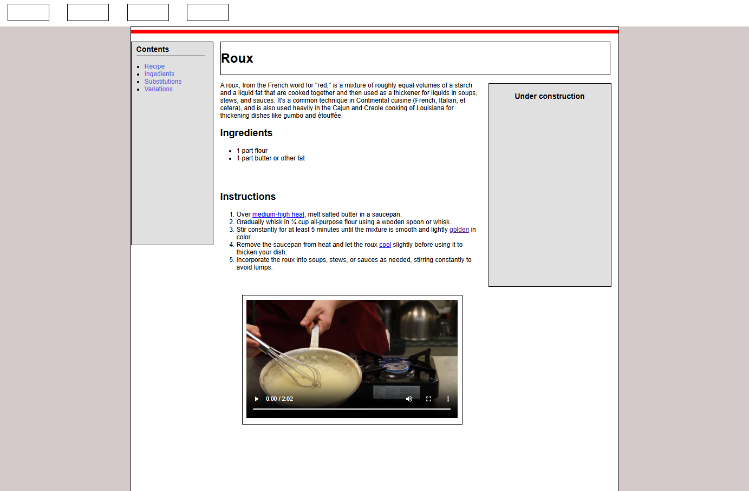  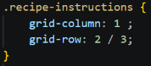  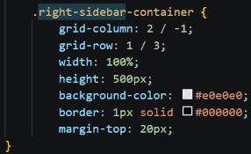  The right-side bar contains an image of the food or item being discussed. It occupies multiple rows but only the far-right column. The idea is that the container should run parallel to the text content and contain some quick reference info like serving size and cooking time.  The result is the image below.

